**JCGV Cinema**

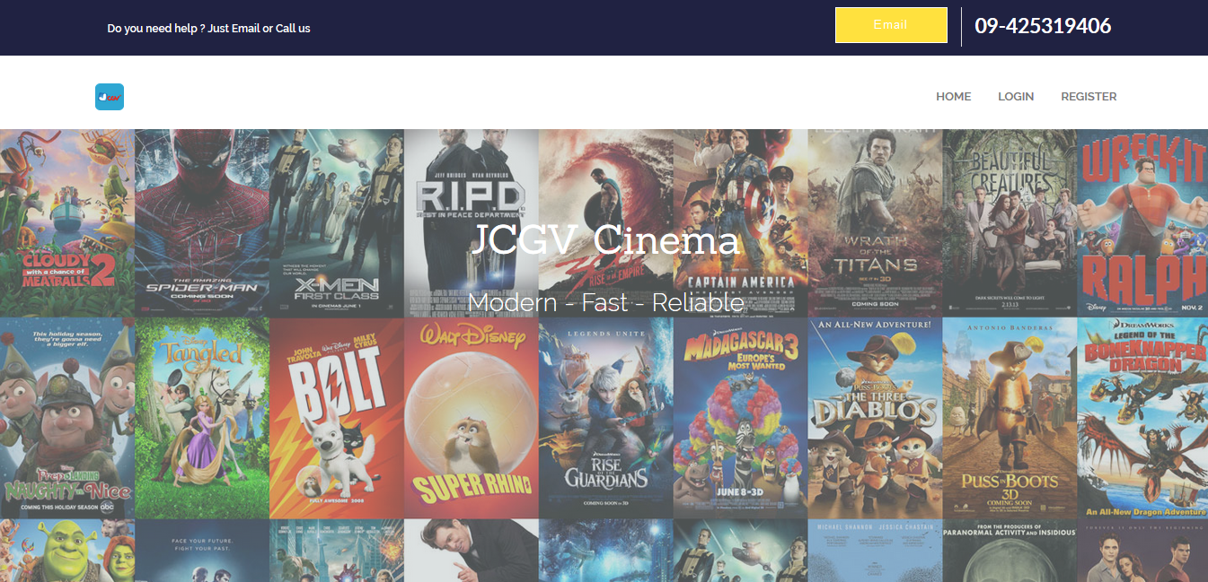

Home page of the website

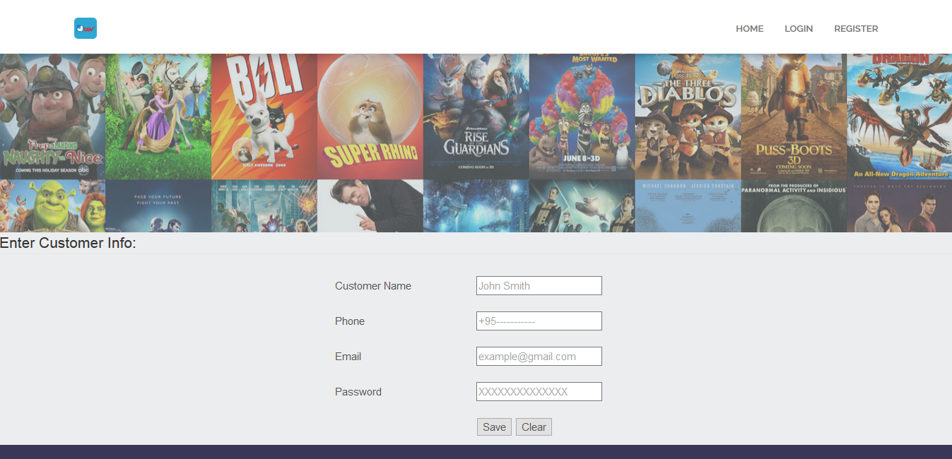

Customer can register the information to make the account

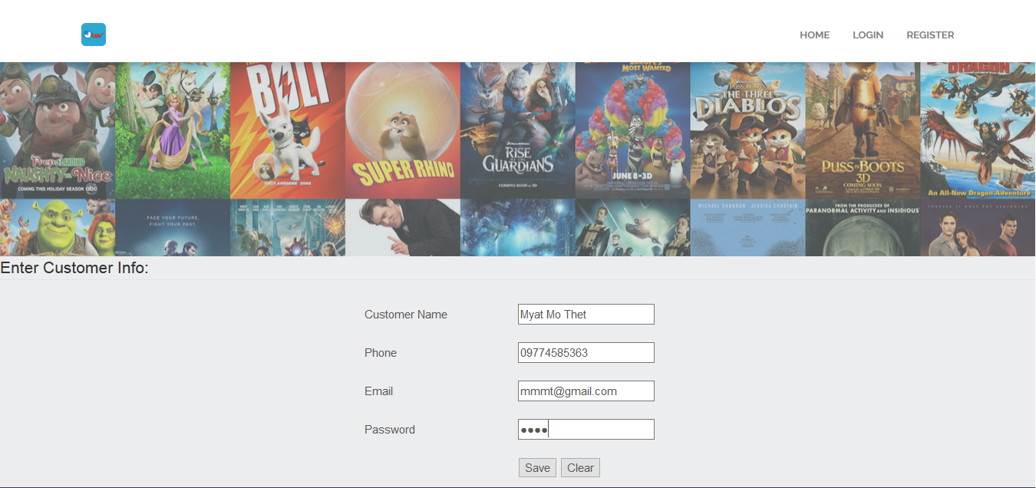

Click the save button to save the data in the database

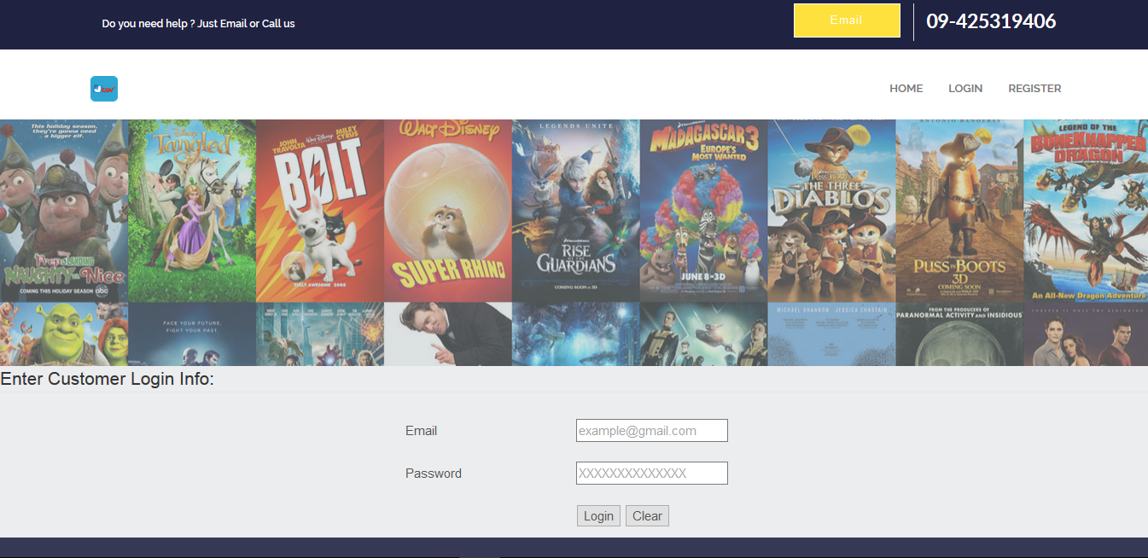

Fill the email which are register in the registration page

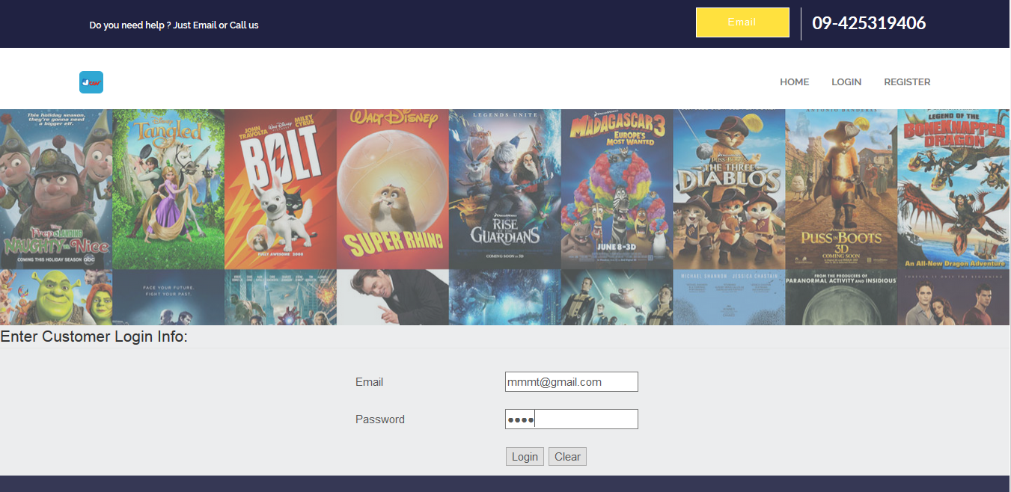

Customer can login to the website use the register email

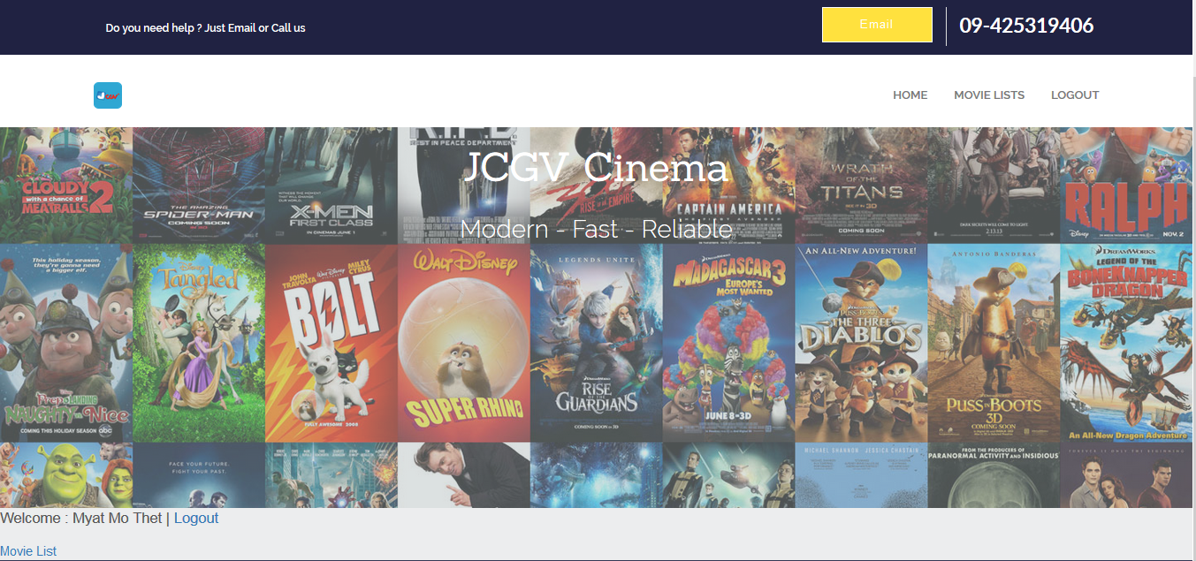

Click the ‘Movie List’ button

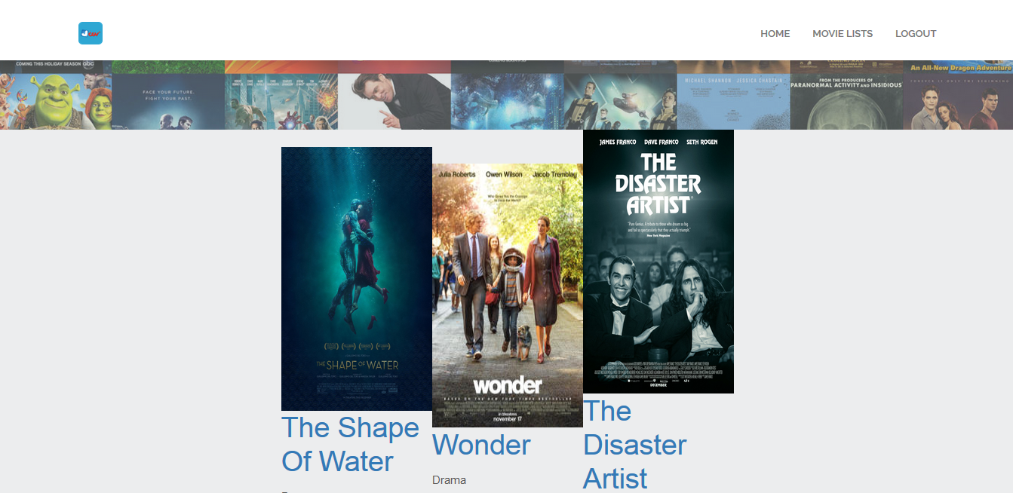

Click on the movie name for show the movie detail

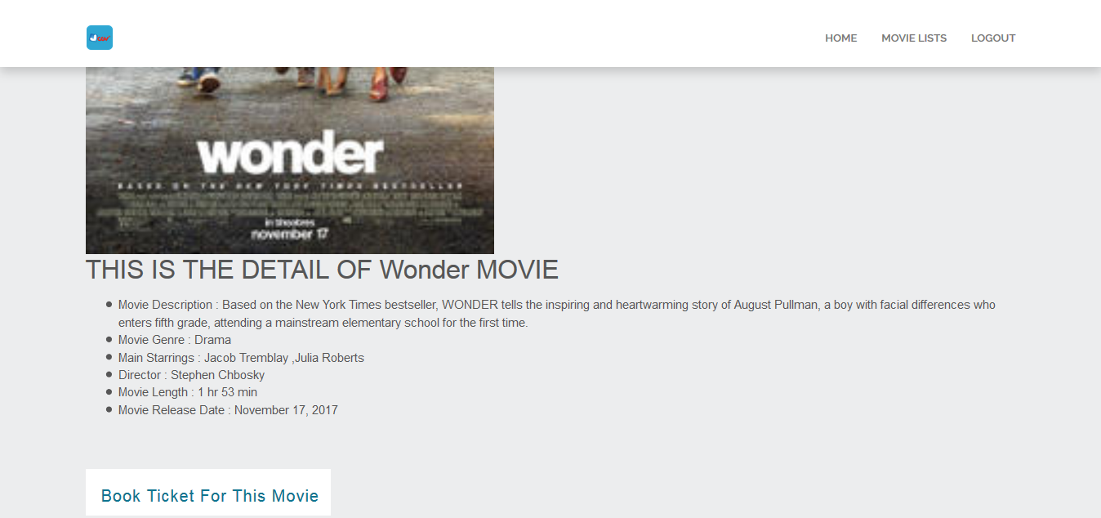

Click the ‘Book Ticket for This Movie’ button for choose the show time and date

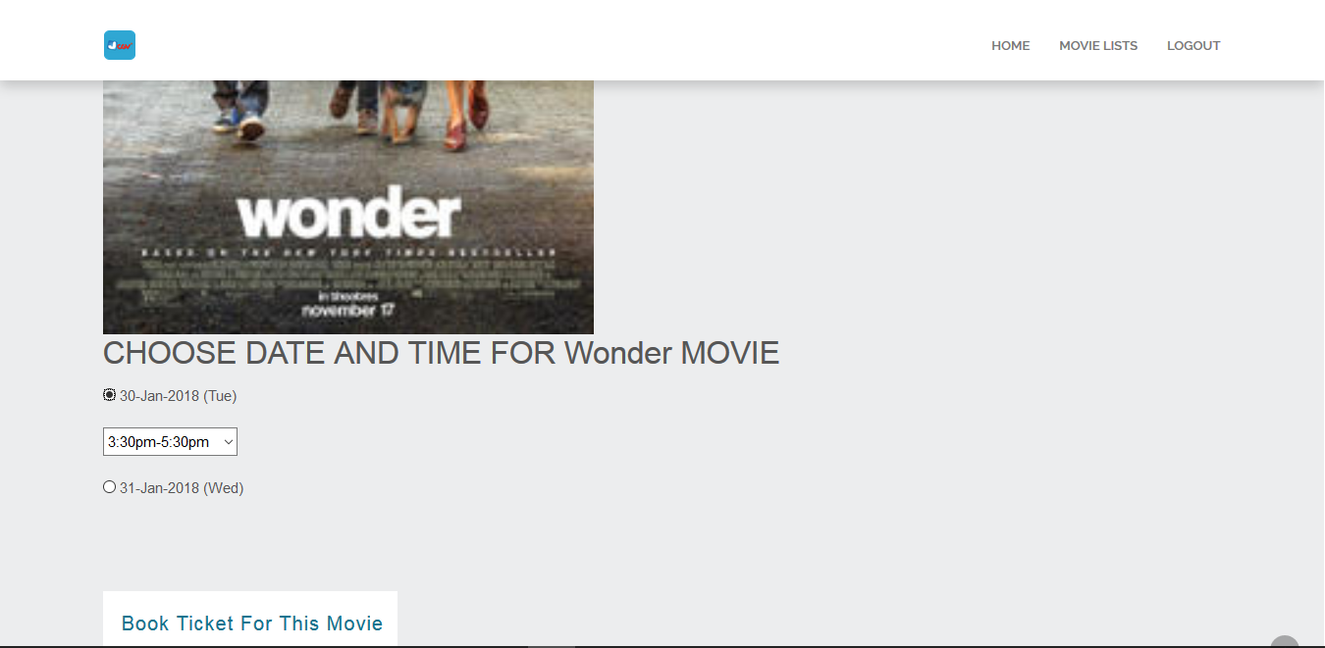

Click on the date and choose the show time and then click the ‘Book Ticket for This Movie’ button

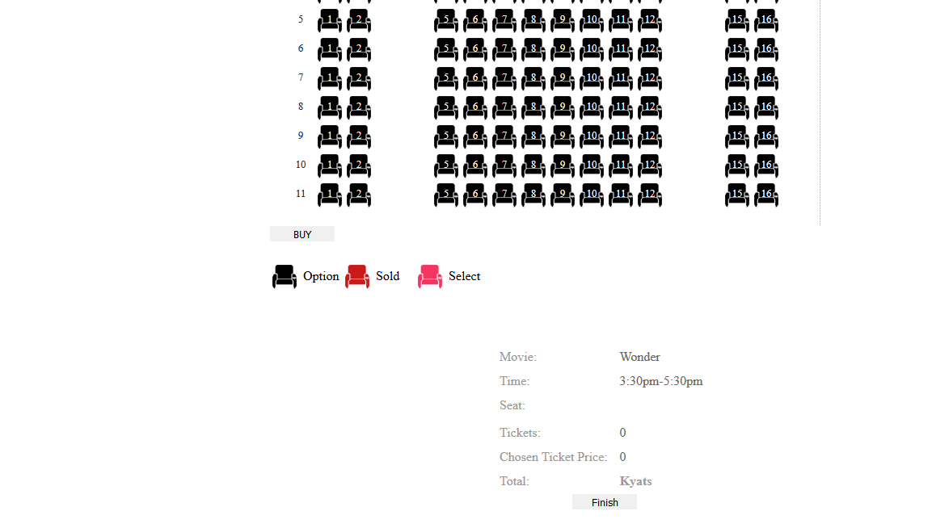

Click the seat which u want to book and then click the ‘BUY’ button

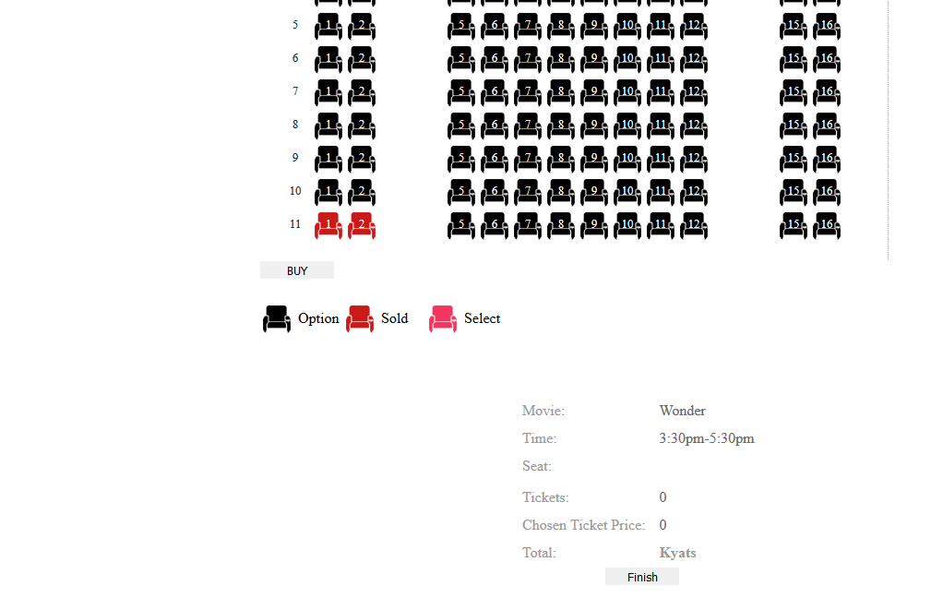

After buying the seat click the ‘Finish’ button

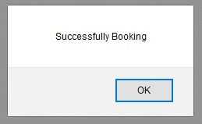

Your booking will be success and click the ‘ok’ button for view the voucher

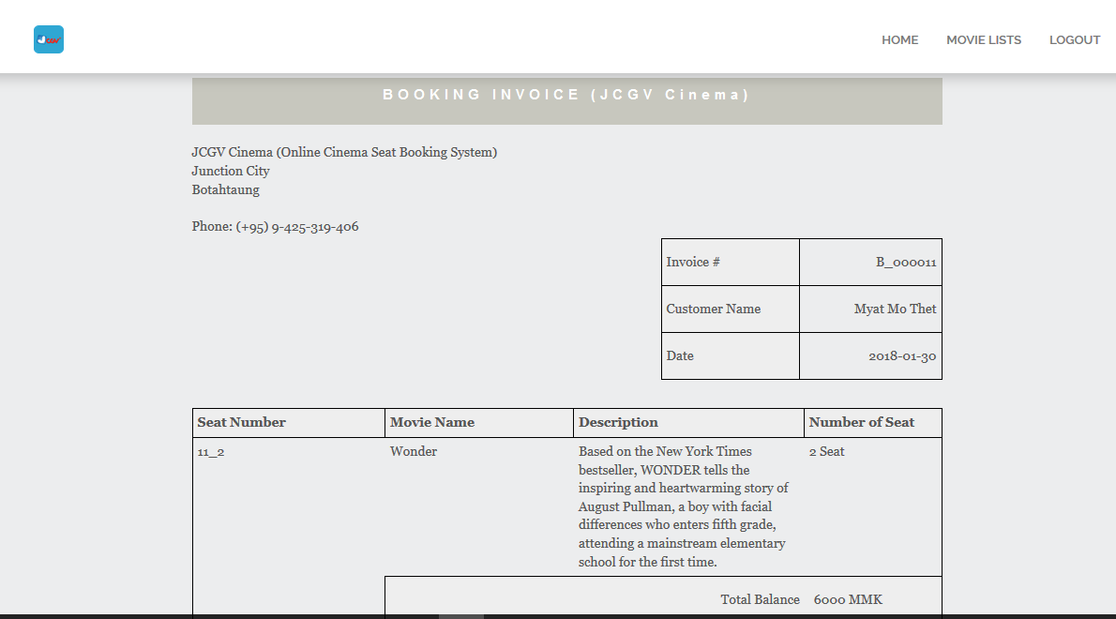

The voucher will be print out

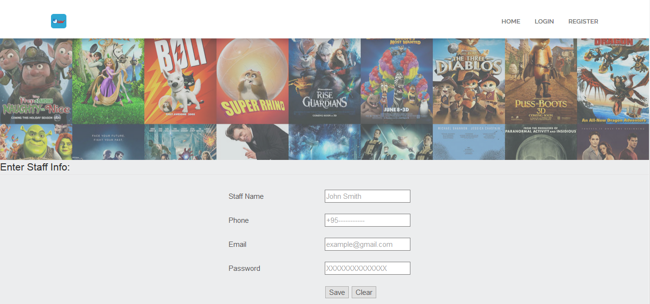

Fill the staff information into the text box

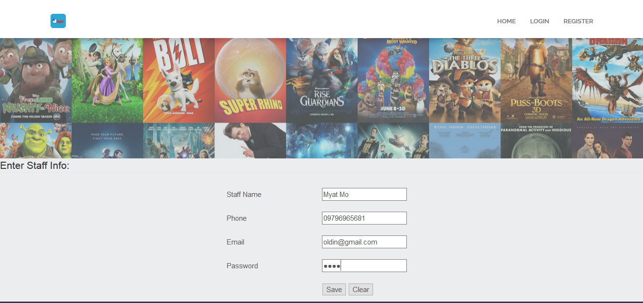

Click the ‘Save’ button for save the information in the database

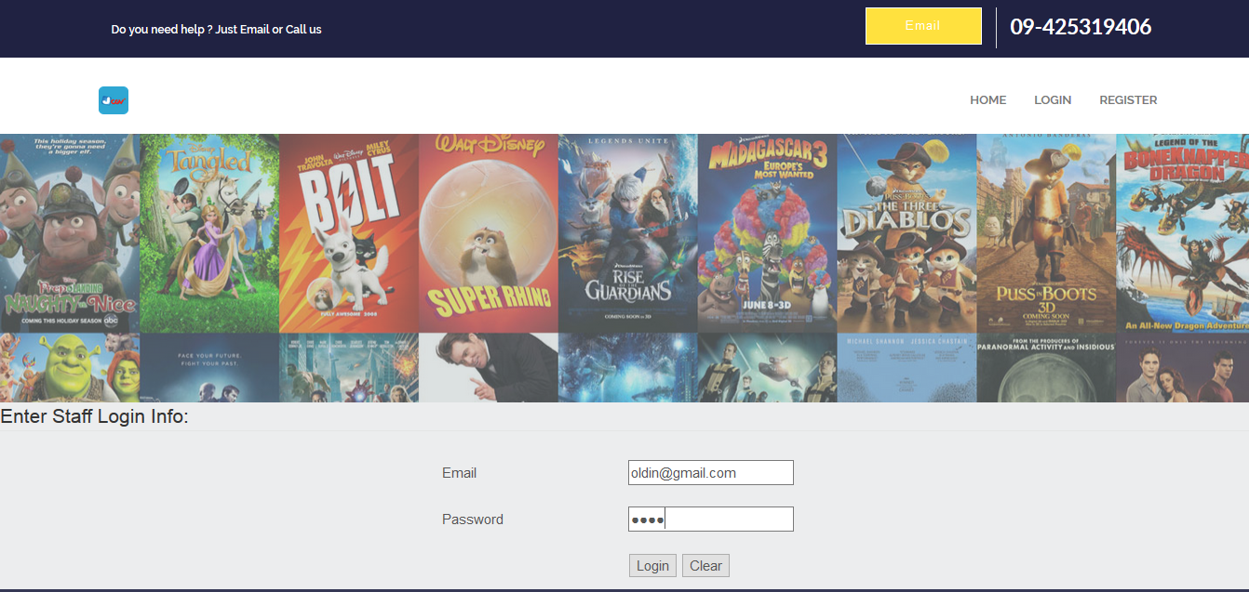

Fill the staff email and click the ‘Login’ button for login to the website

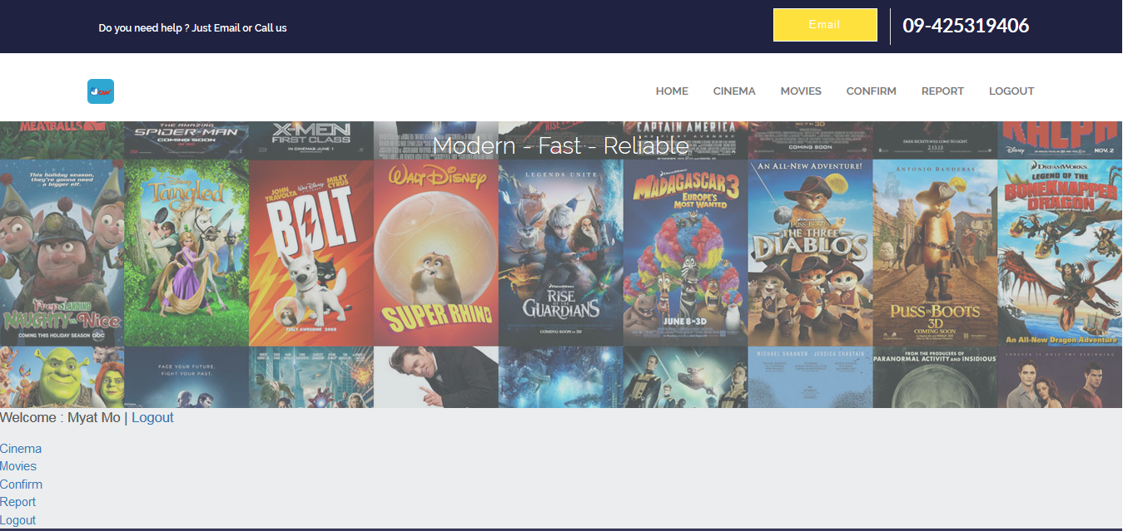

Click the ‘Cinema’ button for add the cinema

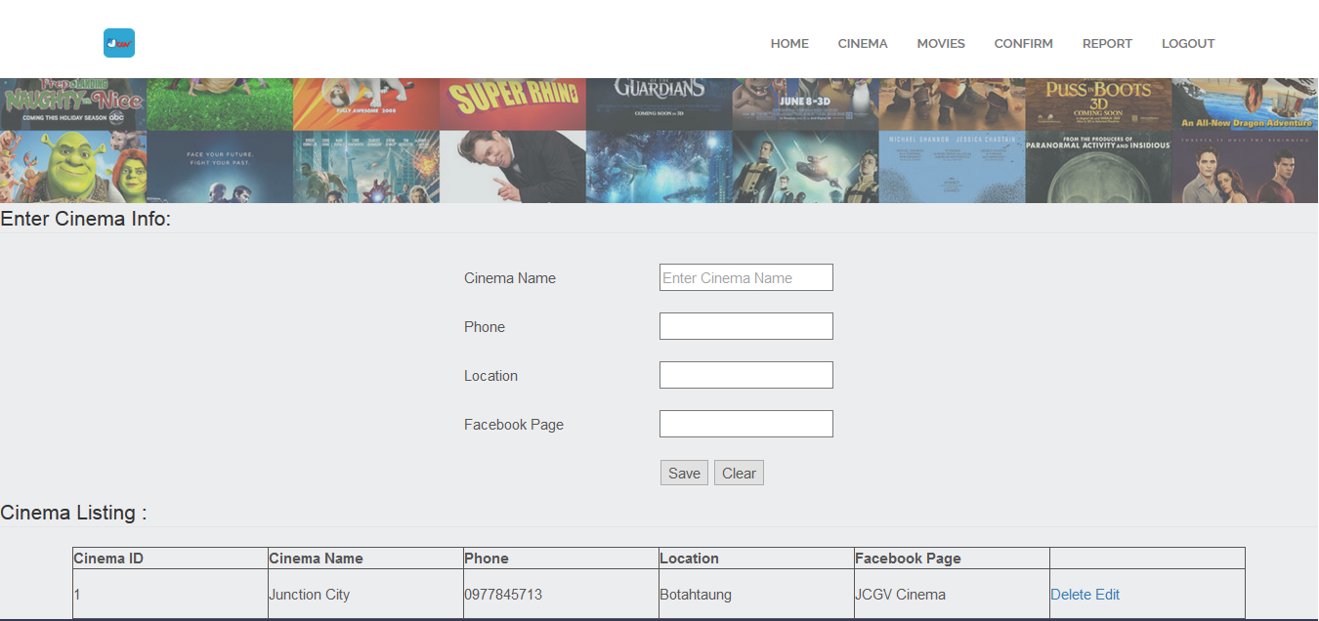

Fill the detail information of cinema in the text box

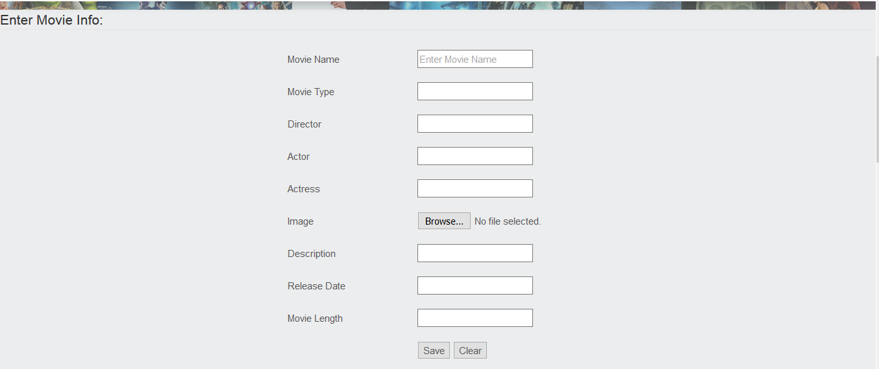

Click the ‘Movie’ button at the left top of the page and fill the detail information of movie in the text box

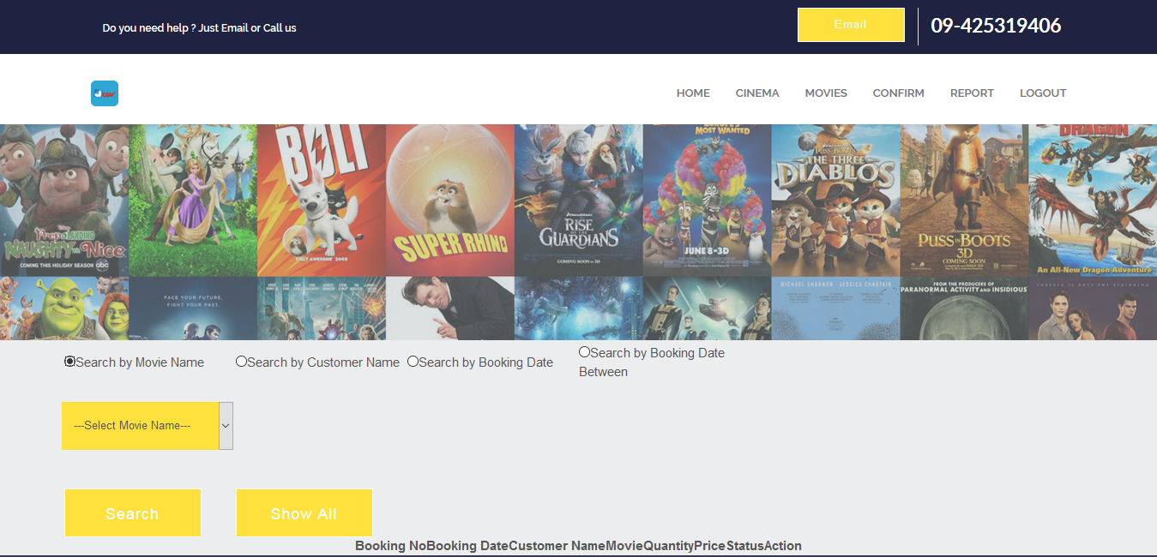

Click the ‘CONFIRM’ button at the left top of the page and then search the booking

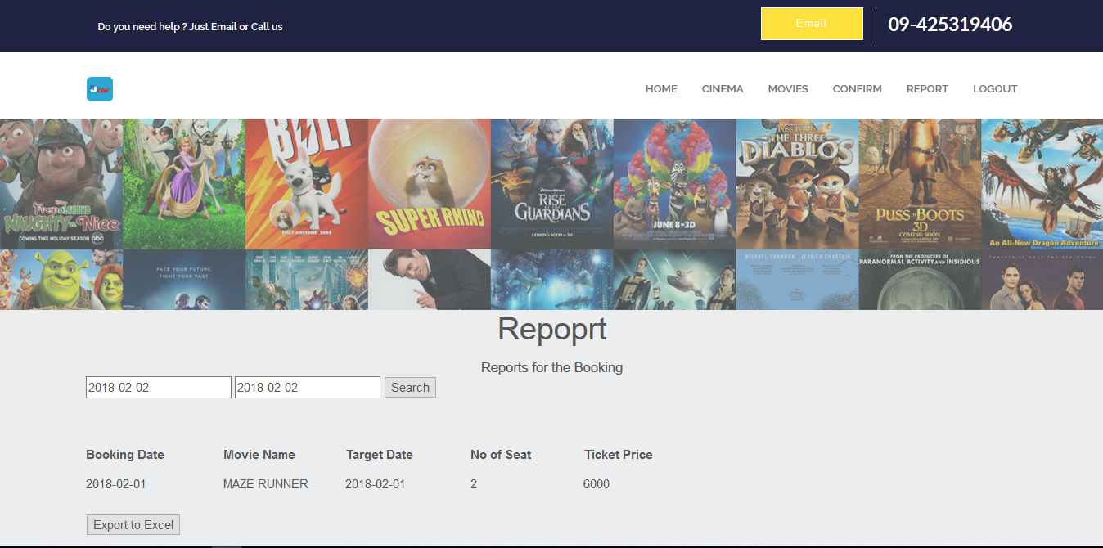

The report may be print out